Annual Report - 2021
For (RAK Courts Department)

TABLE OF CONTENTS
Director General's Speech/Introduction: 1
Government Entity Framework 3
Vision 3
Mission and Values 3
Main Tasks 3
Organizational Starcture 3
Provided Services 3
Achievements 4
Strategic Indicators Results 4
Operational Outputs Results 7
Completed Projects and Initiatives 9
Service Indicators and Customer Experience 12
Human Capital Management Results 13
Legislative Framework and Public Policy Development 14
Amended Laws and Regulations Issued This Year 14
Laws and regulations under study for development or amendment .
Community Responsibility and Participation .
Initiatives, Contributions, and Events 16
Strategic Partnerships, Agreements, and Government Cooperation 19
Awards and Honors 20

List of Tables:

Table 1 - Strategic Indicator Results Error! Bookmark not defined.
Table 2 - Operational Indicator Results Error! Bookmark not defined.
Table 3 - List of Projects and Initiatives 11
Table 4 - Service Indicators 12
Table 5 - Human Capital Results 13
Table 6 - Government Laws and Regulations 14
Table 7 - Laws Under Study Error! Bookmark not defined.
Table 8 - Initiatives, Contributions, and Activities Error! Bookmark not defined.
Table 9 - Government Partnerships 20

List of images

Image 1: Organizational Structure 3

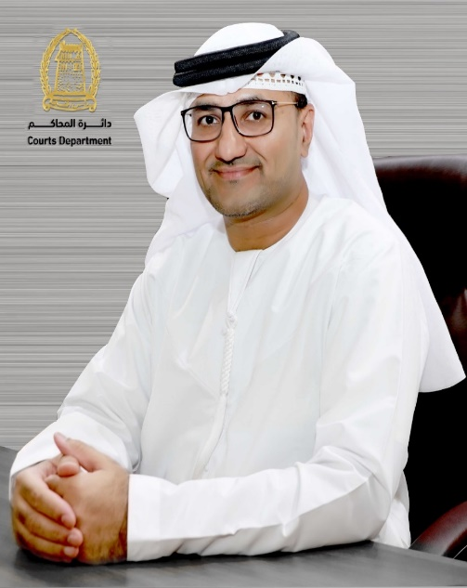
General Director Speech/ Introduction:

Creativity and innovation have become a principle and an essential feature to achieve excellence and leadership in RAK Courts, which is an approach and method of work that Department has been following for a long time, based on directions of State Government and vision of the wise leadership. Technical development and digital transformation in various fields have become an urgent necessity to enhance quality of life for the society of the Emirate. Among the most important strategies launched in this regard is the strategy of "Paperless Courts", through which we seek to zero customers, and turn all services into fully smart, as Courts have been able to make great leaps at various levels, to complete transactions of the public and apply for services from home without the need to attend in person to service centers. However, Courts Department was able to transform challenges imposed by Covid-19 pandemic into opportunities and achievements, through exceptional efforts provided by work teams in Courts that resulted in business continuity with high efficiency and quality, and with agility that contributes to its excellence, without stopping any service, but this contributed to speed of obtaining the service, delighting customer and saving time and effort at the same time, this confirms the determination of the teamwork to continue its work to the fullest, and to make unremitting efforts to overcome challenges, with the aim of Continuity of work, facilitating the customer and obtaining the required service would not have been possible without the unlimited support of His Highness Sheikh Saud bin Saqr Al Qasimi, Supreme Council Member and Ruler of Ras Al Khaimah, and the continuous follow-up of His Highness Sheikh Mohammed bin Saud Al Qasimi, Crown Prince of Ras Al Khaimah and Chairman of the Judicial Council.
Courts Department is keen to adopt international best practices to ensure the simplification of procedures and speed of performance, achieve prompt justice among all litigants, and keep pace with global changes and developments in technical and scientific environment, to provide exceptional, advanced and pioneering services to customers that exceed their expectations and aspirations in line with the "UAE Centennial 2071", "UAE Vision 2021", and "Ras Al Khaimah Vision 2030".
Courts were also able to achieve pioneering achievements during the year 2021, including launch of 16 smart judicial services for customers through mRAK application, launch of digital signature service for judges through UAEPASS, issuance of guide to regulate personal status issues, and the first judicial

department to provide Union Credit Bureau with judicial financial information and obligations in its credit reports which enhance the comprehensiveness of reports and the credit environment in the State, and issuance of decision to regulate the profession of matchmakers in the Emirate of Ras Al Khaimah.
It also won advanced positions in the Government Excellence Award 2021, the first place in the digital services platform of Government of Ras Al Khaimah, second place in the category of the best website for Government of Ras Al Khaimah, and second place in the category of the best innovative service initiative (Execution of judgments and decisions with Saaed).
The issuance of this annual report on RAK Courts comes with the aim of reviewing the achievements during the year 2021, and in order to achieve Courts' commitment to the highest standards of transparency, monitoring the most important decisions, new regulations, initiatives and projects that have been launched, and providing correct and accurate information, in addition to documenting works for reference at any time as a comprehensive and reliable reference for all works and efforts exerted.

Speech by H.E. Ibrahim Ahmed Al Zaabi
Director General of Ras Al Khaimah Courts Department

Framework of the Government Entity:

Vision: Leading Justice for a Happy Society

Mission: Achieving justice and legal protection for society by relying on qualified human cadres, modern technologies and effective cooperation with all concerned authorities

Values: Fairness, Independence and Credibility, Excellence and Innovation, Transparency, Loyalty and Belonging, Social Responsibility

Main Tasks:
- Documentation and Endorsements

- Dispute Resolution and Litigation

- Execution of Judgments

Organizational Chart
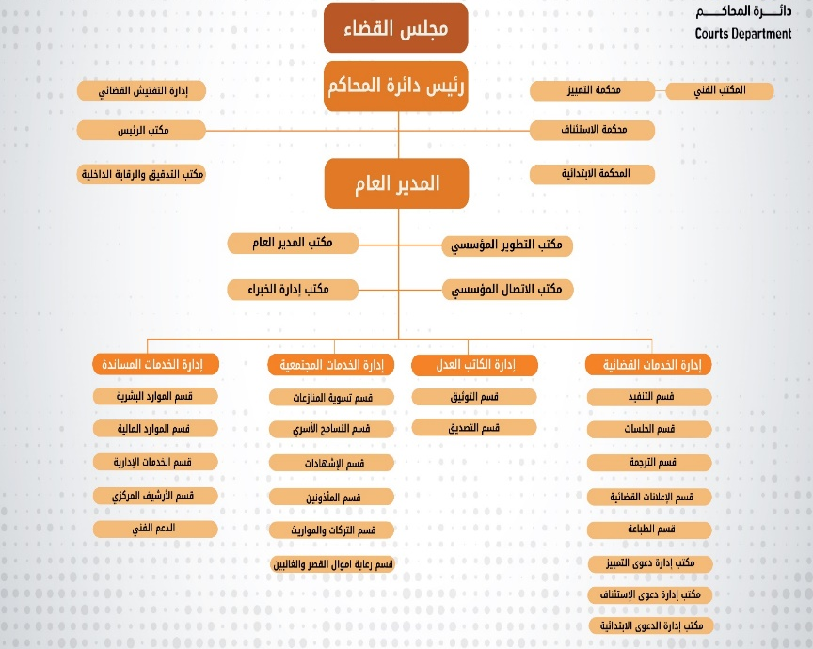

1 organogram

Services Provided
Courts Department provides the following main services to its clients:
- Judicial services: These services include registration of lawsuits, procedural judicial requests, execution of judgments, requests for execution of judgments, and service of process.
- Services Documentation: Includes certificates, inheritances, powers of attorney, contracts, declarations and marriage
- Family Reform Services: Includes counseling and family dispute resolution
- Dispute Resolution Services

Services are provided to various customer segments. There are three main customers categories: individuals, business and government. Customer categories vary according to the main services to:
- Judicial Services: Individual, Business and Government Categories
- Notary Services: Individual and Business
- Certification, Marriage, Inheritance and Family Reform Services: Individual Category

Achievements:

Outcomes of Strategic Indicators:
- Enhancing confidence in the judicial system and raising the level of competitiveness
Indicator | Target |  |  | Achieved |  |  | Remarks
Indicator | 2019 | 2020 | 2021 | 2019 | 2020 | 2021 | Remarks
Percentage of adjudicated lawsuits | 95% | 95% | 95% | 99.27% | 96% | 96
Average age of adjudicated lawsuits | 50 | 50 | 50 | 48 | 28 | 33
Rate of General Execution | 50% | 50% | 50% | 74% | 40% | 54%
Execution timeframe | 1000 | 1000 | 500 | 1614 | 376 | 442

- Strengthening the role of amicable settlements and judicial mediation in achieving stability and community happiness
Indicator | Target |  |  | Achieved |  |  | Remarks
Indicator | 2019 | 2020 | 2021 | 2019 | 2020 | 2021 | Remarks
Percentage of reconciliation and settlement in family cases is 48% | 50% | 60% | 60% | 57% | 57% | 61%
Percentage of conciliation and settlement in lawsuits | 25% | 25% | 25% | 28% | 28% | 20%

- Strengthening institutional development services and innovation
Indicator | Target |  |  | Achieved |  |  | Remarks
Indicator | 2019 | 2020 | 2021 | 2019 | 2020 | 2021 | Remarks
Job happiness | 80% | 80% | 80% | 70 % | 70 % | 70 %
Emiratization ratio | 65% | 65 | 65% | 77% | 59% | 58% | Percentage of Emiratization was calculated without (members of the judiciary – experts – office assistant– Public Relation Officers).  As for the total localization rate with all job groups = (45.5%
Percentage of commitment to the budget | 100% | 100% | 100% | 85 % | 95% | 87 % | This percentage is related to the budget commitment of expenses, planned against actual  We were unable to adhere to the target as a result of estimating amounts for the new building that were not fully disbursed, and the full amounts planned by IT were not disbursed
Percentage of growth in revenues | 2% | 2% | 7% | 7% | 10% | 20% | There is no growth in revenues for 2020 due to the Corona pandemic  Growth in revenues during 2021 as a result of the collection of deferred lawsuits fees
Percentage of employees benefiting from innovative training programs | 85 % | 84 % | 100% | 85 % | 85 % | 54%

- Strengthening the relationship with partners and the community
Indicator | Target |  |  | Achieved |  |  | Remarks
Indicator | 2019 | 2020 | 2021 | 2019 | 2020 | 2021 | Remarks
Percentage increase in joint initiatives and projects | 40% | 50% | - 50 | 42% | 53% | - 50
Partner Happiness Score | 75 % | 80% | 85 % | 78% | 80% | 80%

- Excellence in providing services and improving the customer experience
Indicator | Target |  |  | Achieved |  |  | Remarks
Indicator | 2019 | 2020 | 2021 | 2019 | 2020 | 2021 | Remarks
Customer Happiness | 75 % | 80% | 85 % | 78% | 80% | 90%
Degree of quality of electronic and smart services | 85 % | 90% | 95% | 86 % | 90% | 96%
E-Transformation Ratio | 50% | 90% | 98% | 55% | 92 % | 99.9 %
Percentage of electronic use | 50% | 65% | 75 % | 57% | 75 % | 78%
·

Results of operational outputs:
Indicator | Target |  |  | Achieved |  |  | Remarks
Indicator | 2019 | 2020 | 2021 | 2019 | 2020 | 2021 | Remarks
Average age of adjudicated lawsuits | 50 | 50 | 50 | 47 | 28 | 33
Average period for lawsuits registering | 15 | 15 | 15 | 8 | 7 | 7
Average period for lawsuit management | 45 | 45 | 45 | 14 | 15 | 2.0
Average period of litigation | 40 | 40 | 40 | 3?: 1_%. | 11 | 12
Total Registered lawsuits | - | - | - | 5723 | 5432 | 6198
Total First Instance Lawsuits | - | - | - | 4474 | 4397 | 5169
Total Appeal Lawsuits | - | - | - | 981 | 859 | 868
Total Cassation Lawsuits | - | - | - | 268 | 176 | 161
Age of adjudicated first instance lawsuit | 50 | 50 | 50 | 44 | 28 | 33
Average age of registration (First Instance) | 15 | 15 | 15 | 8 | 7 | 7
Average age of lawsuit management (First Instance) | 45 | 45 | 45 | 13 | 15. | 2.0
Average age of litigation (First Instance) | 40 | 40 | 40 | 3?: 1_%. | 11 | 12
Average age of the adjudicated Lawsuit (Appeal) | 50 | 50 | 50 | 62 | 33 | 3?: 1_%.
Average age of registration (Appeal) | 15 | 15 | 15 | 8 | 7 | 7
Average age of lawsuit management (Appeal) | 45 | 45 | 45 | 13 | 9 | 11
Average age of Litigation ( Appeal ) | 40 | 40 | 40 | 34 | 1.8 | 14
Average age of cassation adjudicated lawsuits | 50 | 50 | 50 | 50 | 40 | 49
Average age of registration ( Cassation) | 15 | 15 | 15 | 5 | 4 | 6
Average age of lawsuit management (Cassation) | 45 | 45 | 45 | 29 | 22 | 24
Average age of litigation (Cassation) | 40 | 40 | 40 | 16 | 14 | 19
Time Execution Rate | 1000 | 1000 | 500 | 1614 | 376 | 442
Number of Executed Lawsuits | - | - | - | 2451 | 1128 | 1826
Number of registered execution files | - | - | - | 3334 | 2845 | 3351
Transactions volume | - | - | - | 112513 | 114030 | 118450
Total Judicial Services | - | - | - | 62567 | 76075 | 78545
Total notary services | - | - | - | 36104 | 25425 | 26885
Total Community Services | - | - | - | 13805 | 12494 | 12994
Total number of electronic transactions | - | - | - | 38440 | 52094 | 61948
Total family reconciliation cases | - | - | - | 21 | 82 | 240
Total family reconciliation agreements | - | - | - | 358 | 284 | 358
Total referrals | - | - | - | 417 | 275 | 389

Total number of service of processes | - | - | - | 14238 | 15566 | 18545
Percentage of service of process | 99% | 99% | 99% | 98.9% | 95.3% | 94.4%
Average number of days for service of process | 2 | 2 | 1 | 2 | 1 | 2
Total number of online hearings | - | - | - | - | 20370 | 13030
Number of online video hearings with prisoners | - | - | - | - | 354 | 1143
Translation | - | - | - | 206362 | 60,0000 | 533777
Interpretation | - | - | - | 307198 | 200000 | 235173

Completed projects and initiatives:
Project/Initiative | Description of the Project/Initiative | Achievement Date | Impact of project:
Linkage project with the Criminal Investigation Department | Linking the Judicial Department (Lawsuit Management Office - Civil Execution) with Ministry of Interior (Criminal Investigation Department) on decisions issued by Department so that they are sent electronically without issuing a paper decision or a letter | 22 May | - Achieving smart electronic transformation Accelerating the procedures for executing judgments  - Increase employee happiness  - Increasing customer happiness
Matchmakers Initiative | The initiative aims to seek a partner for the other party within the required specifications | Nov-21 | - reserving the rights of those seeking a partner within the legal procedures followed
Digital signature through .UAEPASS | Using digital identity and linking it to the digital services portal to allow all categories of customers to access security and use digital services from all available service channels | Apr-21 | - Secure access to use digital services  - Offering an easy and fast solution to access digital services  - Increasing Customer Happiness
Digital Services | Providing a digital service package for all categories of customers and for all types of services provided in Courts Department (judicial, notary, personal status and family tolerance) | Nov-21 | - Increasing Customer Happiness  - Achieving the government's directions in digital transformation
Smart Reporting System for Strategic Performance Indicators | Introduce analytics and business intelligence to Courts Department to provide greater insight and clarity to decision makers. This system uses strong monitoring and reporting capabilities to measure key performance indicators in the Department .Through the use of web dashboards and mobile phones to show the most important points of view in the field of work , which would consolidate the key information of the systems used by Courts Department, showing through graphs the current status and trends for the previous and future time period of Department's key indicators to enable decision makers at a glance to make real- time decisions | Oct '21 | - Enabling decision-makers to make real-time decisions at a glance  - Consolidate key information for systems used by Courts Department

Judgements publication | Publication of judgments issued by RAK Courts of First Instance, Appeal and Cassation on the website of RAK Courts | Mar-20 | - Publication of Legal knowledge  - Providing access to judgments for all groups of society  - Raising the level of confidence in the judicial system in Courts Department
A community initiative entitled (Our Happiness with Our Vision) | It is a community initiative launched in cooperation with Emirates Association for Social Development to execute judgements of children in custody visitation at the headquarters and branches of the Association for separated families who suffer from repeated challenges and disputes due to the difficulty of agreeing on neutral places to execute judgements of visitation. This initiative aims to provide a fit and appropriate environment to preserve the psyche of children in custody and a desire to seek to reunite these families because of the appropriate environments and potentialities that help provide the appropriate climate for the completion of the visitation process, under the supervision of specialized staff from Family Court whose task is to follow up these cases and submit periodic reports to the Personal Status Execution Judge | 11/1/2021 | - Reducing the percentage of disagreements and disputes between separated families regarding the agreement on neutral places that satisfy all parties to execute the provisions of the vision therein  - Providing a suitable and appropriate environment that preserves the psyche of children in custody  - High percentage of cases requesting to execute the visitation judgements on the premises of the association
Guide to Regulating Personal Status Matters | It is a guide aimed at facilitating procedures on personal status matters and developing appropriate solutions to face the practical problems and challenges resulting from reality and practical application in personal status lawsuits to reach the proper application of the law and principles of Islamic Sharia and unify the work of judges by unifying the principle , procedural and substantive standards in similar lawsuits and removing the challenges they face when applying , all with the aim of reaching a prompt justice that preserves the rights of all family members, achieves family peace and puts an end to the litigation between these individuals, including a great societal impact | 25/5/2021 | - Speedy completion of personal status lawsuits due to the specificity of that lawsuit and its direct impact on the family entity, especially alimony, custody and visitation lawsuits  - Taking effective, appropriate and decisive measures to achieve prompt justice for all family members without discrimination, whether in the judiciary or in execution  - Unifying the procedures of personal status lawsuits from the stage of family guidance through the stage of preparing the case, rendering a judgement and then execution, as well as unifying standards and not over- or under-estimating expenses and wages and organizing custody and vision to achieve a balance between the interest of each party
Linking with Etihad Credit Bureau Initiative | Include credit information related to judicial financial obligations from Ras Al Khaimah Courts Department in its credit reports, making it the first court department in the State to provide credit information to the company .Such initiatives support the vision of the UAE to be among the first and advanced countries to provide the best services and comprehensive government practices to achieve the happiness of all customers | Mar-22 | Enhancing the comprehensiveness of reporting and the credit environment in the country
Abandoned Vehicles Clearance Project | Linking the judge of temporary matters with the police Impound Vehicles to obtain an order on a petition to sell abandoned vehicles | Jan-22 | Achieving smart electronic transformation between Courts Department and the police Impound Vehicles for abandoned cars

Table 1 - List of projects and initiatives

Indicators of Services and Customer Experience:
Indicator | Target |  |  | Achieved |  |  | Remarks
Indicator | 2019 | 2020 | 2021 | 2019 | 2020 | 2021 | Remarks
Percentage of customer happiness about the quality of services | 75 % | 80% | 85 % | 78% | 80% | 90%
Percentage of Digital Transformation | 50% | 90% | 98% | 55% | 92 % | 99.9 %
Percentage of digital usage | 50% | 65% | 75 % | 57% | 75 % | 78%
Customer happiness rate for digital services | 85 % | 90% | 95% | 86 % | 90%
Percentage of increase in the number of subscribers to digital services | - | 30% | 75 % | - | 32% | 79%
Percentage of improvements to services | 50% | 90% | 95% | 54% | 92 % | 98%
Percentage of services documented | 100% | 100% | 100% | 100% | 100% | 100%

Table 2 - Services Indicators

Human Capital Management Outcomes:

Indicator | Target |  |  | Achieved |  |  | Remarks
Indicator | 2019 | 2020 | 2021 | 2019 | 2020 | 2021 | Remarks
Percentage of Employee Turnover | 1% | 5% | 10% | 6% | 6% | 9.7%
Turnover Percentage of Non-Citizen Employees | 1% | 5% | 10% | 10% | 11% | 12.7%
Turnover Percentage of Citizen Employees | 2% | 3% | 5% | 4.10% | 2% | 6%
Average training hours per employee | 26 | 15 | 25 | 27 | 29 | 35
Percentage of Trainees in the Supervisory Category | 100% | 95% | 100% | 96% | 97% | 100%
Percentage of Trainees in the Specialized Category | 100% | 95% | 100% | 98% | 96% | 94%
Percentage of Trainees in the Executive Category | 100% | 95% | 100% | 97% | 98% | 95%

Table 3 4 - Human Capital Outcomes

Legislative Framework and Public Policy Development:

Laws and regulations that have been amended and issued this year
First: Local draft laws, decrees, and decisions.
 | legislation | EXPECTED COMPLETION DATE
 | Law No. 1 of 2021 Annulment Law No. 4 of 2010 on the Formation of a Special Court | Achieved
 | Law No. (2) of 2021 on changing the status of land use, its planning requirements and the authorized use of buildings | Achieved
 | Law No. (3) of 2021 on Imposing the Destination Fee in the Emirate of Ras Al Khaimah | Achieved
 | Law No. 4 of 2021 Regulating the trading of Alcoholic Beverages in the Emirate of Ras Al Khaimah. | Achieved
 | Law No. (5) of 2021 on Cemeteries and Burial of the Dead | Achieved
 | Law No. 6 of 2021 amending some provisions of Law No. 3 of 2015 on technical regulations for the security of facilities. | Achieved
 | Law No. (7) of 2021 on the Regulation of Light Air Sports in the Emirate of Ras Al Khaimah | Achieved
 | Law No. (8) of 2021 Regulating the Occupancy of Some Real Estate in the Emirate of Ras Al Khaimah | Achieved
 | Law No. (9) of 2021 on trading of products and services providing | Achieved
 | Law No. (10) of 2021 on the Competences of the Geographic Information Systems Center | Achieved
 | Law No. (11) of 2021 on the Land Registry in the Emirate of Ras Al Khaimah | Achieved
 | Law No. (12) of 2021 Regulating the Demolition and Removal Works in the Emirate of Ras Al Khaimah | Achieved
 | Real Estate Regulation Draft Law  Apartments and Floors Ownership Draft Law  Notary Public Draft Law | Ongoing after receiving proposals of the Investment and Development Office and Ras Al Khaimah Economic Zone Authority
 | Executive Council Resolution No. (2) of 2021 Regulating the Profession of Matchmakers in the Emirate of Ras Al Khaimah | Achieved
 | Executive Council Resolution No. (3) of 2021 Regulating the Activity of Transporting Passengers in Luxury Vehicles and Limousines in the Emirate of Ras Al Khaimah | Achieved
 | Executive Council Resolution No. 4 of 2021 Issuing the Executive Regulation of Emiri Decree No. 16 of 2020 on Regulating the School Transport Sector | Achieved

17 | Resolution No. 22 of 2021 on Adopting the Guide to Regulate Some Substantive and Procedural Rules in Personal Status Matters | Achieved
18 | Decree-Law No. (16) 2020 on the Organization of School Transportation | Achieved
19 | Emiri Decree No. 19 of 2021 on the Ratification of Lease Contracts | Achieved

Second: Draft federal laws sent to express an opinion on the subject and the wording.
 | Amendment of Criminal Code | Achieved
 | Amending Federal Law No. 28 of 2005 on Personal Status. | Achieved
 | Federal Law No. 6 of 2021 on Mediation for the Settlement of Civil and Commercial Disputes. | Achieved

Third : Legislative Advice
Achieved | on Duplication of Violations between All Entities in the Emirate, Whether It Applies a Local Law or a Federal Law | 1
Achieved | on Inquiring About the Mechanism of Refunding the Judicial Fees Due to Private Law Persons | 2
Achieved | On Duplication of Violations and Fines between the General Command of Ras Al Khaimah Police and Ras Al Khaimah Transport Authority. | 3
Achieved | on Placing Registration and Monitoring System in Places of Arrest and Detention | 4
Achieved | Coordinating between the police in the State to reduce losses resulting from obstructing the disposal of seized vehicles. | 5
Achieved | On the need for coordination between the Emirate of Dubai and Ras Al Khaimah to reduce losses caused by obstructing the disposal of impounded vehicles. | 6
Achieved | On Emirates Auction Company payment of the transfer fees of the possession of vehicles with metal plates issued by the Emirate of Dubai. | 7
Achieved | on the Disposal of Abandoned and Lost Properties | 8
Table 4 - Government Laws and Regulations

Community Responsibility and Engagement
Courts Department was able to overcome the circumstances imposed by the Covid-19 pandemic by transforming these challenges into opportunities and coming out of the crisis with lessons learned by launching and organizing initiatives and events virtually in social media channels and through direct video communication technology, in order to reach the largest possible segment of society, which contributed to the non-stopping of any initiative, as the year 2021 witnessed several initiatives of 100 events, the most prominent of which was

Initiatives, contributions and events
Initiative/ Event | Description of Initiative/ Event | Achievement Date | Impact
My Experience Knowledge Transfer Initiative. | These are knowledge meetings to share a summary of the experiences and expertise of court presidents, judges, directors of organizational units, and any employee who has long experience, to transfer them to employees from all departments. | throughout the year | - Enhancing internal communication between officials and employees of the Department.  - Dissemination of specialized knowledge and expertise  - Increasing knowledge and access to the experiences of those with long experience.
Health Awareness Initiative "Healthy Life..Positive spirit | An integrated educational health program for the Department's employees that includes all areas of interest to their public health, either in person or remotely through workshops and lectures, in cooperation with RAK Medical University and the University of Sharjah. | throughout the year | - Paying attention to the mental and physical health of employees and raising their awareness of health risks.  - Keeping them safe and improving job performance.  - Awareness and education of employees in terms of health.
Campaign to vaccinate court employees with the anti-COVID-19 virus | A health campaign was launched to vaccinate all court employees with the COVID-19 vaccine, in cooperation with the Ministry of Health and Prevention, to maintain the health of employees from the coronavirus. | 7/2/2021 | - Reducing the cases of those infected with Corona and limiting the spread of the virus.  -Providing a healthy and safe work environment free of diseases.  - Maintaining the health and safety of employees.  - Spreading awareness of the importance of receiving the vaccine.
Previewing innovative court initiatives at UAE Innovation Week. | The UAE Innovation Month was interacted with by presenting court innovations virtually through 5 social media channels, in addition to holding virtual sessions to discuss innovation in judicial services. | February | - Highlighting court innovations.  - Interacting with the directions of Ras Al Khaimah Government on participating in the month of innovation.
5 Virtual Initiatives Launched for 'Reading Month' | Courts Department participated in the activities of the National Reading Month 2021, under the slogan "My Family Reads" with a package of initiatives and events that are organized virtually, targeting all employees of the Department, which is a book compass competition, a new age credit event, a book listening initiative, an enriching links initiative, and a cursory reading event. | March | - Enhancing the cognitive aspect of employees.  - Encourage employees to read and instill the same as a daily habit.  -Creating positive competition among employees.
Congratulating the children of employees on their success in high school | It is an initiative in which employees were congratulated on the occasion of their children's graduation and success in high school by sending special congratulations in the name of the employee's son and sharing them in front of the employees to congratulate the employee on the success of his son. | 7/7/2021 | - Participation of employees in their joys.  - Increasing social ties between employees.  - Promoting a friendly and communicative atmosphere.  - Enhancing the outreach of the Communication Office with employees.  - Spreading happiness and pride of their children.  - Exchanging congratulations among employees on various occasions.
Promotional campaign for the World Expo 2020 Dubai. | A promotional campaign was implemented for employees to encourage them to buy Expo tickets by highlighting the importance of the event. | 26/09/2021 | - Encourage employees to buy Expo tickets.  - Cooperation in making the success of the global event .  - Increasing the number of visitors to the exhibition.  - Supporting national programs and events hosted by the State.

Bonyan Card Gift Platform Initiative for Employees | Collaboration was carried out with Dubai Municipality through the provision of a Bonyan card team and the placement of an electronic device at the headquarters of Courts to gift the card judges and Emirati employees. | 22-11-2021 | Staff Satisfaction  - Strengthening the relationship with government entities.  - Saving expenses to employees when buying household supplies.
Initiative to celebrate the fiftieth anniversary of the UAE National Day | The UAE's 50th National Day was celebrated with a traditional Arab tent, popular cuisine, and a military band performance. | 28/11/2021 | - Participating in the state's celebrations of its national day.
Offers and discounts initiative to delight employees | It is an initiative through which special offers and discounts were provided to court employees in cooperation with partners. | throughout the year | Staff Satisfaction  - Achieving financial savings.  - Achieving the greatest benefit for employees.  - Enhancing cooperation with the authorities.
Initiatives5 , contributions and events

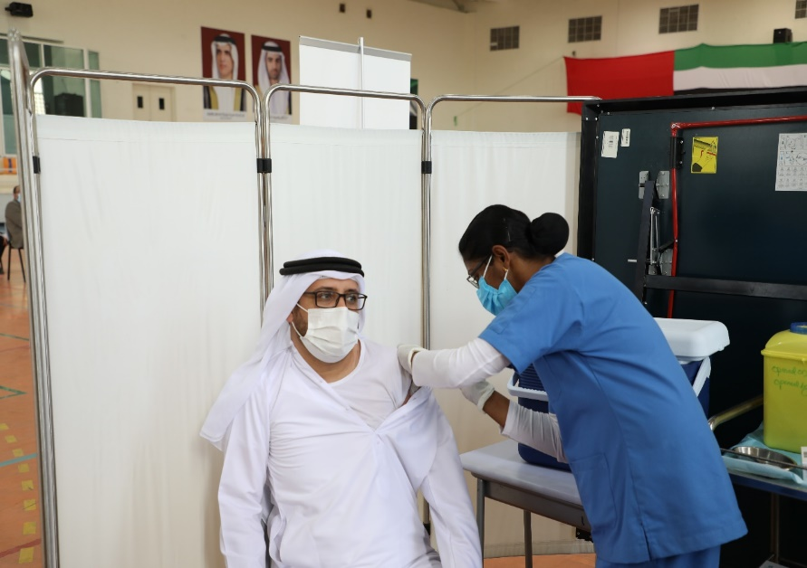
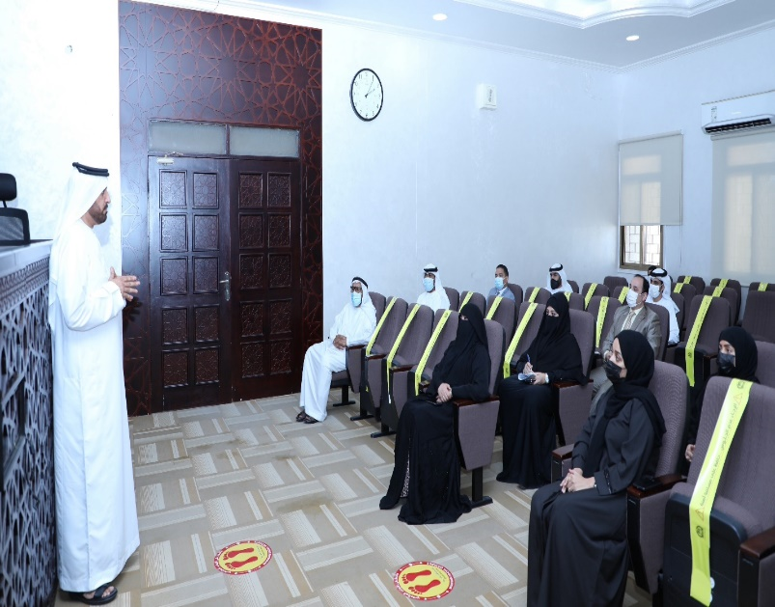
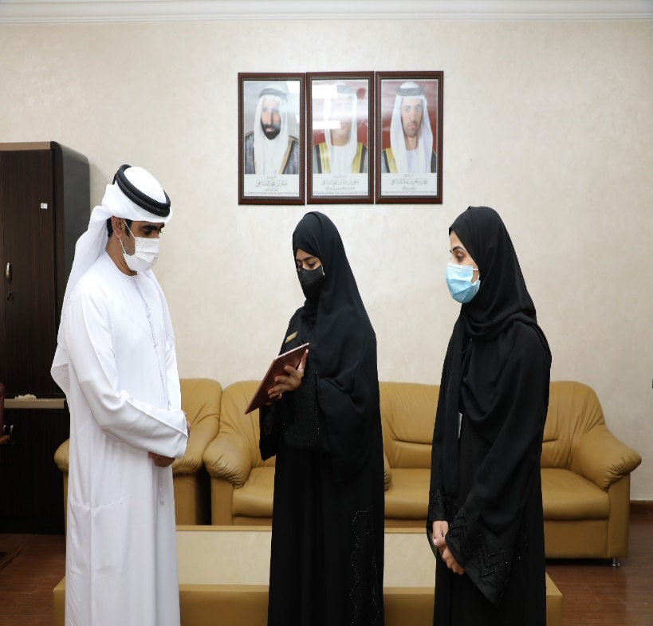
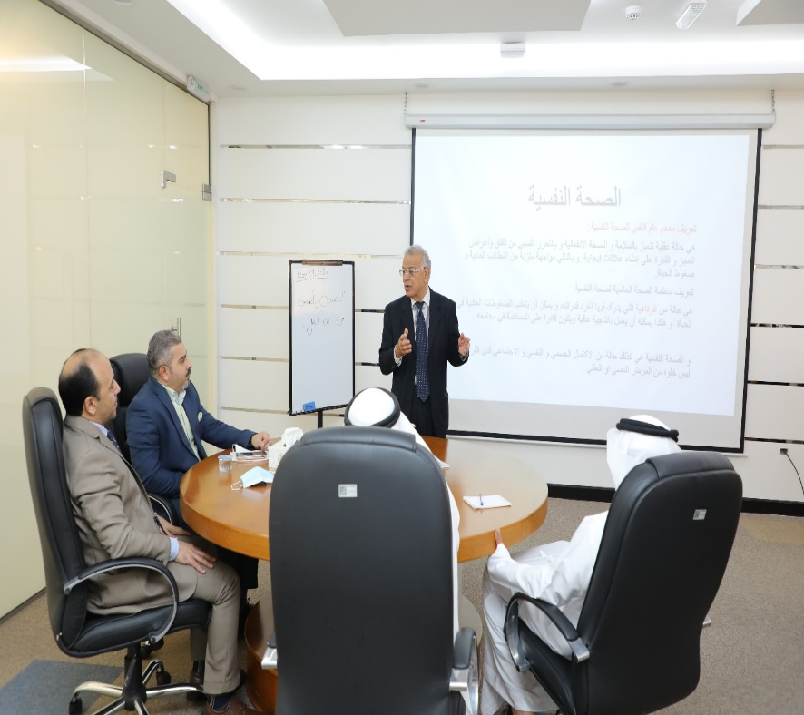
Knowledge meetings within My Experience initiative Employee vaccination campaign for COVID-19
Implementation of a promotional campaign for Expo 2020 Dubai Health Awareness Program
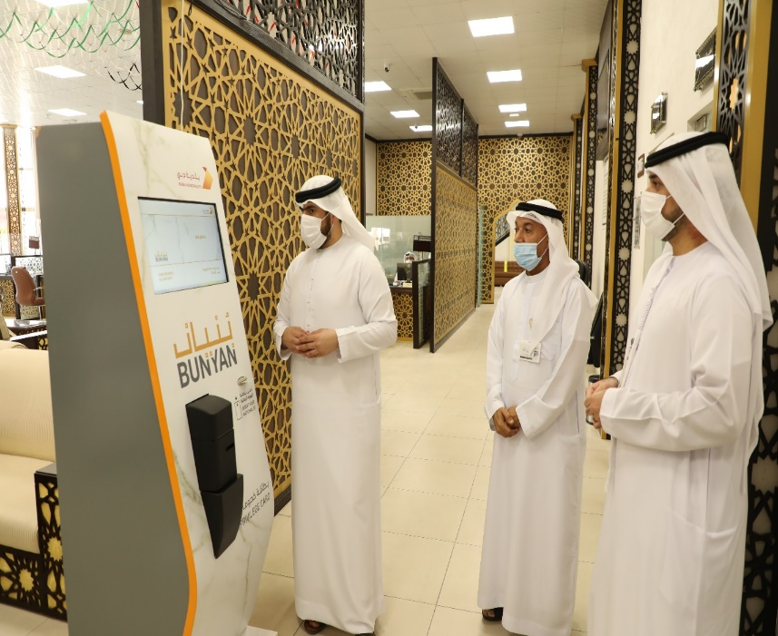

Celebrating the UAE 50th National Day Implementation of Bonyan Initiative
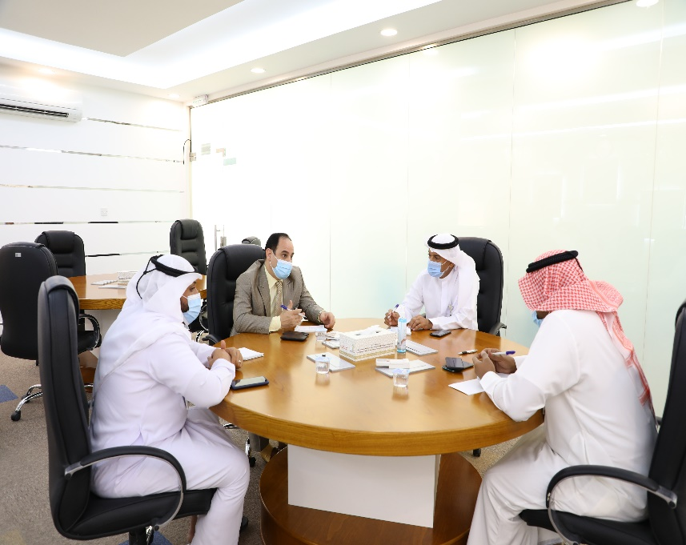
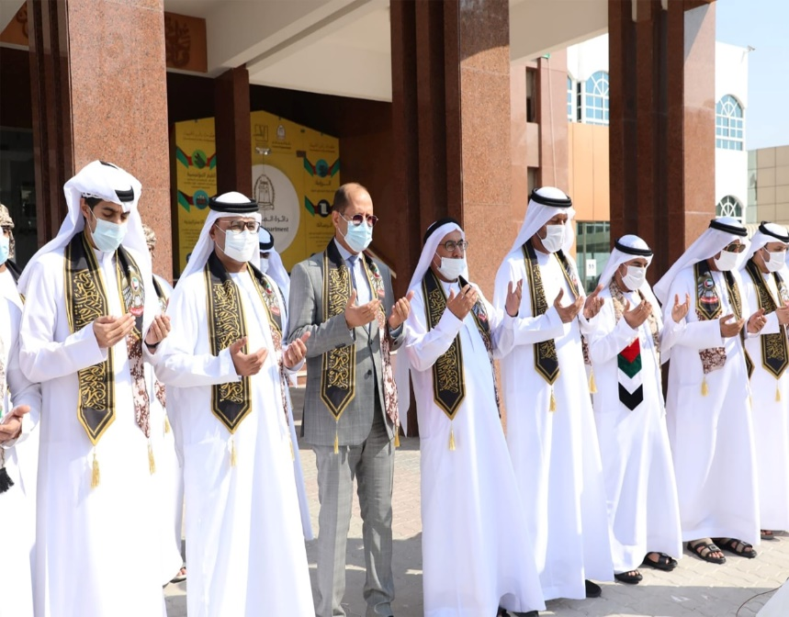

Martyr's Day event Cultural session to promote reading

Strategic Partnerships, Agreements and Government Cooperation:

Planning partnerships and their relationship in order to support Courts strategy, ensure the success of their work and facilitate their communication with the concerned authorities, thus ensuring an effective impact on the work environment and society in order to achieve sustainable benefit at the practical level. Coordination has been made according to the protocol of agreements adopted by the Department, with the public and private sectors to enhance communication and joint work, which contributes to improving the performance of operations, simplifying procedures, developing services and supporting development efforts. It has been signed with 3 government and private entities, namely:
Partnership | Partnership areas | Initiative/ Activity/ Agreement Implemented | Impact
Etihad Credit Bureau | Periodically provide the obligations of the adjudicated parties in civil lawsuits and the status of payments related to the execution parties in financial claims lawsuits | Electronic Link | Improving the comprehensiveness of credit reports for individuals and companies alike.
Emirates Intellectual Property Association | - Development of intellectual property services and exchange of experiences  - Exchanging data, information, publications, bulletins, laws, studies and practices applied by both parties in the fields of intellectual property rights and others.  - Using the latest awareness methods in the field of intellectual property and its legislation.  - Adoption of the Intellectual Property Expert Diploma Program | -Signing a partnership agreement | -
Etihad Medical and Dental Center | - Granting the employees of Department discounts and privileges on all medical and therapeutic services provided by Union Medical Center.  - Enhancing cooperation in the health and medical fields. | Signing Partnership Agreement | Obtaining special discounts for employees of RAK Courts and their first-degree relatives by 40% on all medical and health care services that include medical consultations in various specialties provided by the Center, dental treatments, radiology services, laboratory services, medical tests and physiotherapy.
Table 6 - Government Partnerships
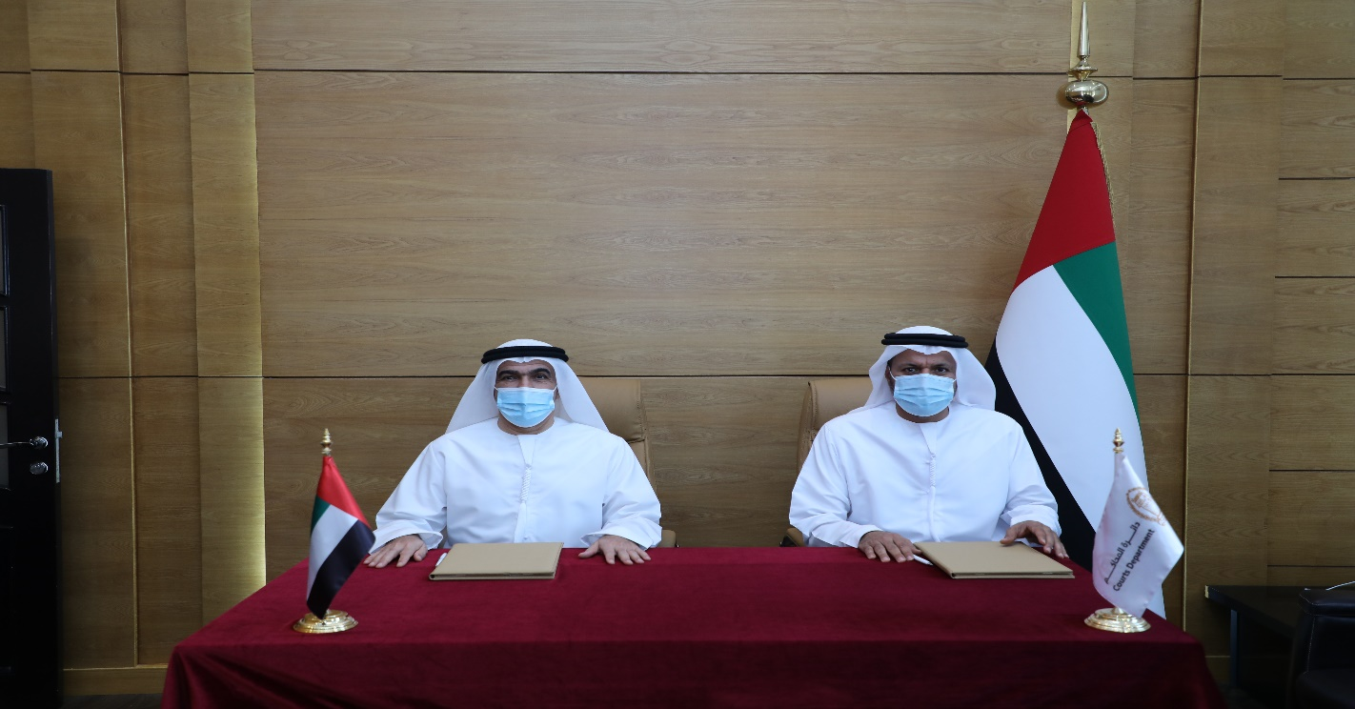

Signing a cooperation agreement with the Emirates Intellectual Property Association
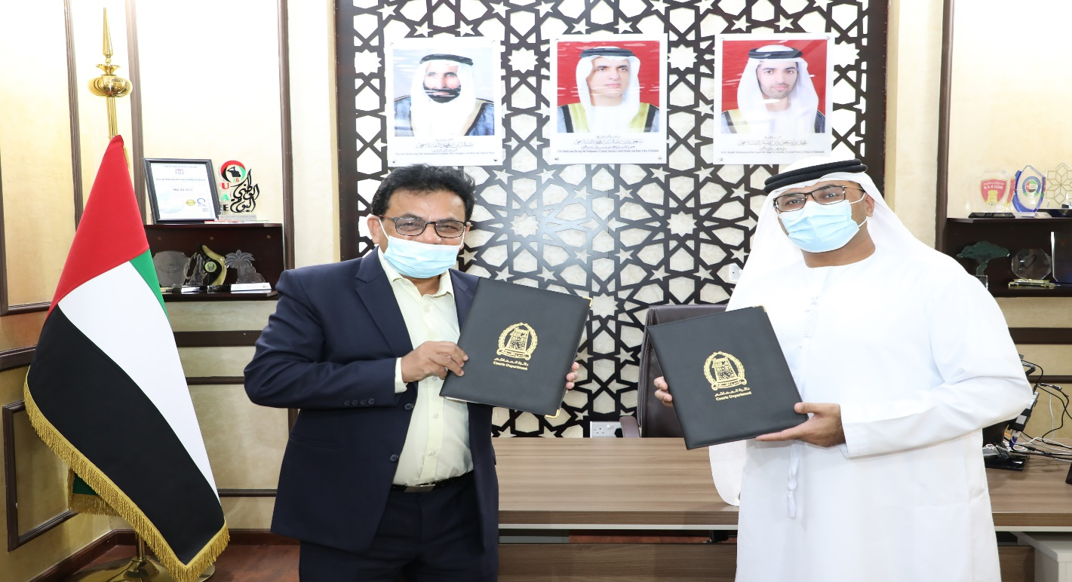

Signing a cooperation agreement with Union Medical and Dental Center

Awards and Recognitions:
- First place in the Digital Services Platform of the Government of Ras Al Khaimah - Sheikh Saqr Award for Government Excellence 2021
- Second place in the category of the best website for the Government of Ras Al Khaimah - Sheikh Saqr Award for Government Excellence 2021
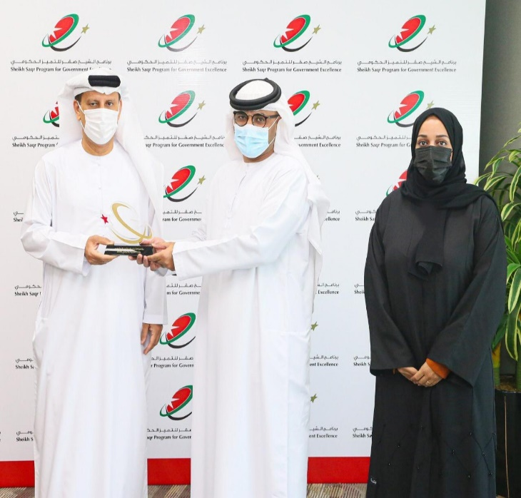
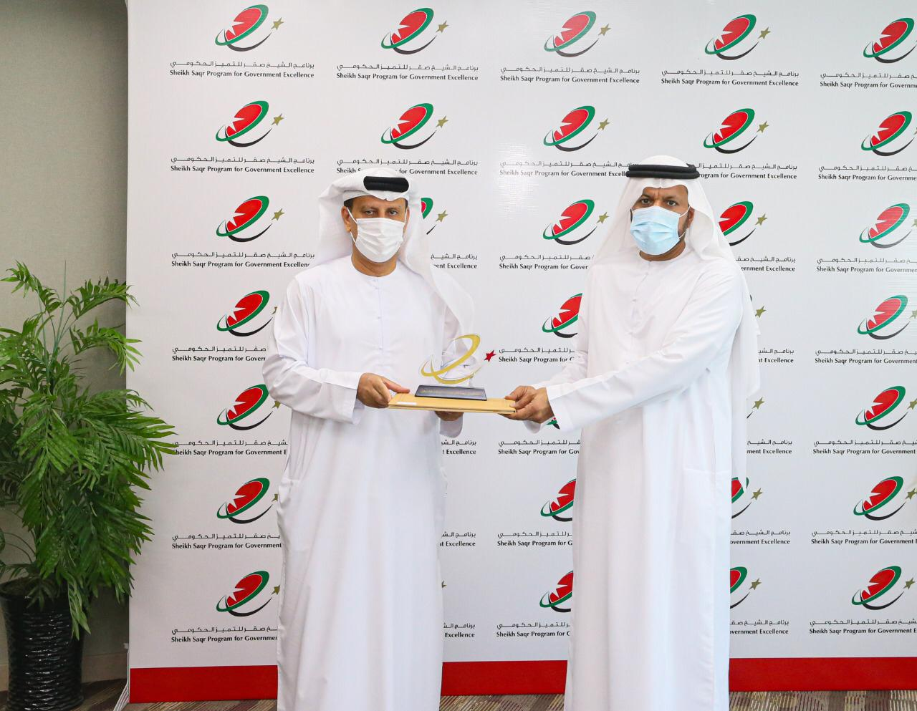
- Second place in the category of Best Innovative Service Initiative (Initiative to execute Judgments and Decisions with SAAED Company - Sheikh Saqr Award for Government Excellence 2021

