Annual Report
RAK Courts


His Highness Sheikh
Saud bin Saqr Al Qasimi
Member of the Supreme Council and Ruler of Ras Al Khaimah


His Highness Sheikh
Mohammed bin Saud bin Saqr Al Qasimi
Crown Prince of Ras Al Khaimah and Chairman of Judicial Council
Table of Contents:
Message of RAK Courts’ President 4
Government Authority Framework: 6
Organizational Structure: 7
Services Provided: 8
Achievements: 9
Strategic Performance Indicators: 9
Completed Projects and Initiatives: 15
Work in Progress: 16
Legislative Framework and Development of General Policies: 17
Strategic Partnerships, Memoranda of Understanding and External Agreements: 19
Awards & Honors - Photos: 22

Table List:
Table 1 – Strategic Performance Indicators 9
Table 2 - Key Result Indicators 10
Table 3 – Human Capital Management Results 13
Table 4 – Work in Progress 14
Table 5 – Work in Progress 15
Table 6 - Legislative Framework and Development of General Policies 16
Table 7 – Partnerships 20

Image List:
Image 1 – Organizational Structure 6

Chart List:
Chart 1 – Average Age of Decided Cases 11
Chart 2 – Cases Filed in 2016-2022 12
Chart 3 – Volume of Services Provided in 2016-2022 12
Chart 4 – Actual Revenue in 2015-2022 10
Chart 5 – Total Number of Staff Members 13

Message of RAK Courts’ President


“Excellence, creativity and innovation in the institutional work are considered an integrated system and a prerequisite for our government agencies for the government workplace development according to the highest universal quality standards,” said His Highness Sheikh Saud bin Saqr Al Qasimi, Member of the Supreme Council and Ruler of Ras Al Khaimah, may God bless him.
Therefore, RAK Courts devote efforts to the provision of efficient, quality services with creative, proactive thinking for all citizens and residents of the emirate, which contributes to the wise leadership’s vision and aspirations as well as RAK government’s orientations and the enhancement of the society’s quality of life. Thanks to the infinite support and sponsorship of His Highness Sheikh Saud bin Saqr Al Qasimi, Member of the Supreme Council and Ruler of Ras Al Khaimah, may God bless him, and His Highness Sheikh Mohammed bin Saud bin Saqr Al Qasimi, Crown Prince of Ras Al Khaimah and Chairman of Judicial Council, the Courts Department managed in 2022 to carry out a number of leading projects and launch several modern services and creative initiatives, including but not limited to the launch of the Courts’ new corporate identity depending on four main elements, namely justice, universality, efficiency, and happiness in line with its strategic plans and orientations and readiness for the next fifty years. The Courts Department also managed to digitally provide 96% of the Department’s services around the clock and launch the service of “the electronic filing of the family cases” which minimized the number of the people frequenting the Family Court premises for filing cases, not to mention the “remote” family tolerance sessions and the receipt of the ISO 50001 Certificate for Energy Management Systems.
The Courts Department used to keep its customers happy and live up to their expectations by providing advanced digital services to keep abreast of the cutting-edge technology and enable customers to receive services in an easy, quick manner without the need for going to the Courts’ premises. The Courts Department provided the “Facile” service which enables customers to instantly message the various sections of the Department, file applications and receive replies to inquiries. It also provided “remote” services to the customers using modern techniques and held court hearings using videotelephony technology. Having reviewed the results and reports of the “Happy Visitation” initiative, we found out marked decrease in repeated dysfunctional family disputes over agreement to neutral places. All of those achievements made in 2022 had a tangible role in improving the customer experience to such an extent that exceeded customer expectations and aspirations.
At last, RAK Courts take confident, balanced steps towards a bright future for advanced judicial work using the world’s best practices. The Courts Department will continue to expend its best efforts with grim determination making use of the available advanced possibilities to develop and implement plans and programmes and launch judicial, notarial and community services which will enormously contribute to the judicial system development and bring citizens and residents happiness and wellbeing. The Courts Department will also endeavor to expand its sustainable relations with the current and prospective strategic partners, either federal or local government agencies, to achieve its strategic goals and cultivate close long-term corporate relations that will promote cooperation, coordination and integration for the execution of joint ventures, contribute to success and offer assistance and support.
It is a pleasure to express big thanks and gratefulness to the staff for the good job they did, the hard, faithful effort they expended for the development of the service provided and the improvement of the customer experience and the contribution they made to success.
We promise our customers more development and improvement of services and double teamwork efforts for prompt justice.

Ahmed Mohamed Al-Khateri
RAK Courts President

Government Authority Framework:

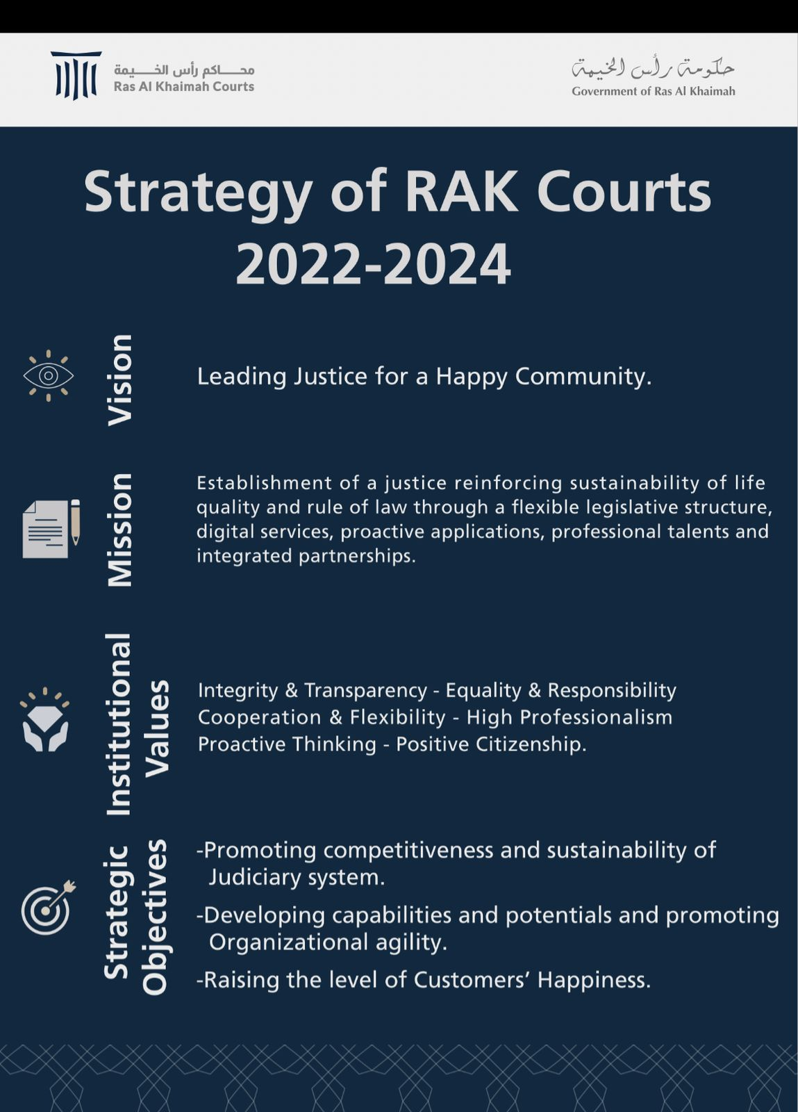

Essential Functions
Judgment Enforcement | Dispute Resolution & Litigation | Attestations and Legalizations

Organizational Structure:

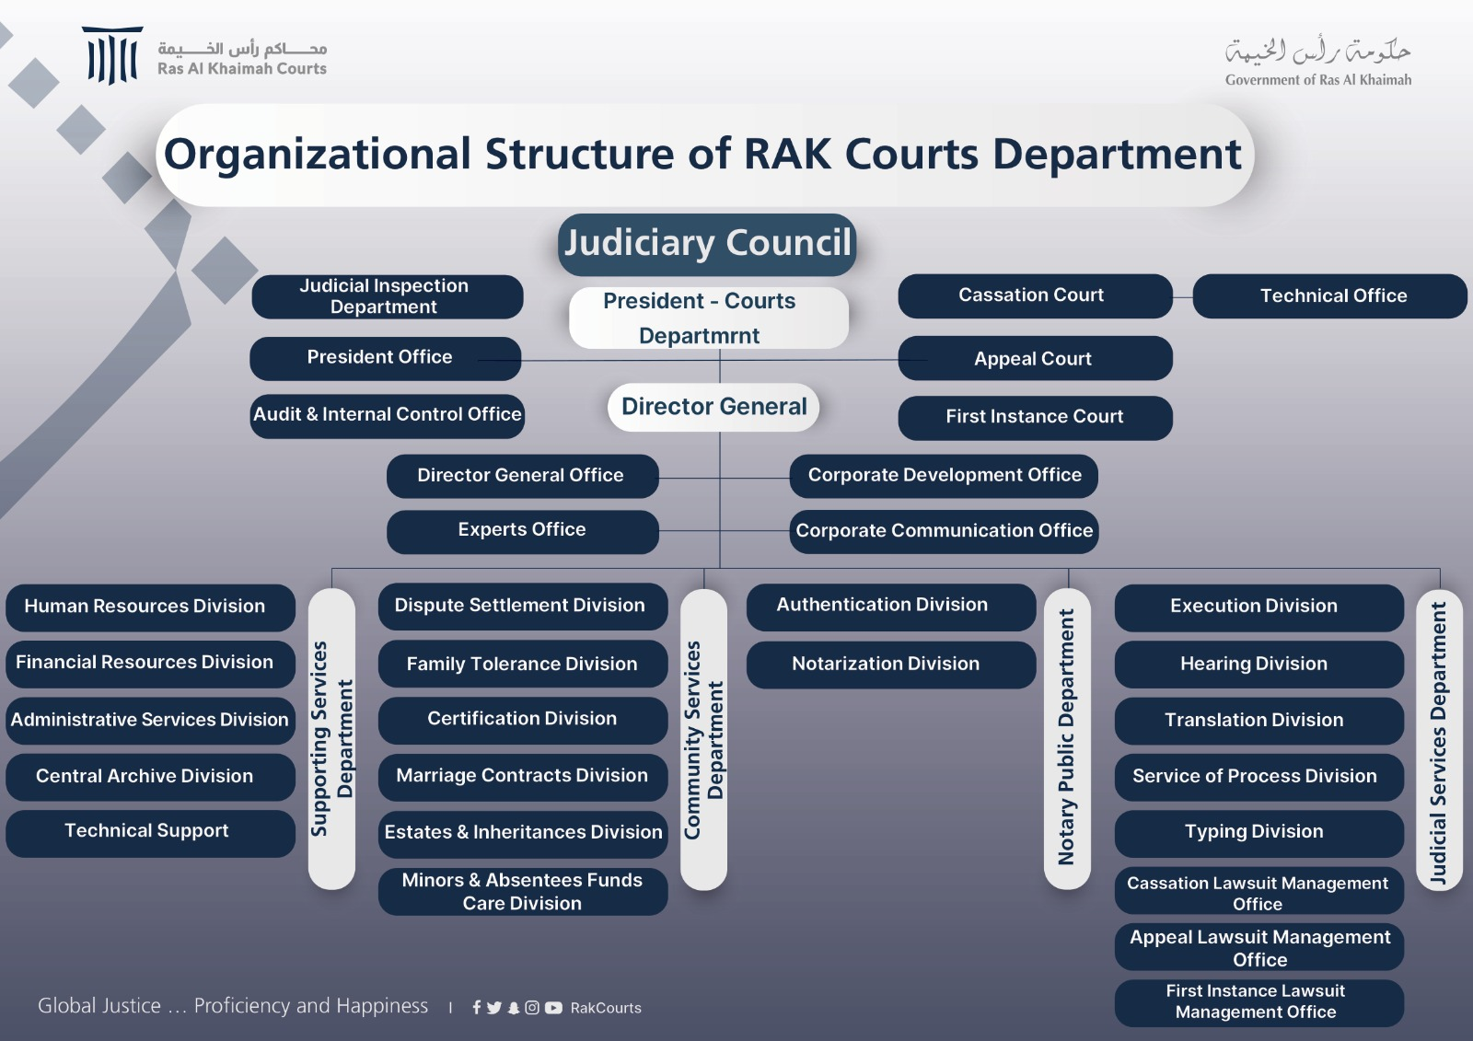

Image 1: Organizational Structure

Services Provided:

The Courts Department provides the following main services to its customers:
Judicial Services | Notarial Services | Marital Reconciliation Services
Including lawsuit filing, procedural motions, judgment enforcement services, judgment enforcement applications and service of process services | Including certificates, probate divisions, powers of attorney, contracts, declarations and marriages | Including lawsuit filing, procedural motions, judgment enforcement services, judgment enforcement applications and service of process services
 | Dispute Settlement Services
Services are provided to the various classes of customers, which are three main classes, namely individual, business and government customers. The main services provided to the abovementioned classes of customers are as follows:
Judicial Services | Notarial Services | Certification, marriage officiation, probate division and marital reconciliation
Individual, business and government customers | Individual and business customers | Individual customers

Achievements:
- RAK Courts digitally provide 96% of its services around the clock.
- RAK Courts notarize marriage contracts for non-Muslims.
- RAK Courts receives the ISO 50001 Certificate for Energy Management Systems

Strategic Performance Indicators:

Strategic Goal | Indicator | Target |  |  | Deliverable
Strategic Goal | Indicator | 2020 | 2021 | 2022 | 2020 | 2021 | 2022
Judicial System Competitivity and Sustainability Enhancement | Adjudication Rate | 95% | 95% | 95% | 96% | 96% | 99%
Judicial System Competitivity and Sustainability Enhancement | Decided Case Average Age | 50 | 50 | 50 | 28 | 33 | 36
Judicial System Competitivity and Sustainability Enhancement | Judgment Accuracy Rate | 90% | 90% | 90% | 96% | 94% | 94%
Judicial System Competitivity and Sustainability Enhancement | Overall Enforcement Rate | 50% | 50% | 50% | 40% | 54% | 45%
Judicial System Competitivity and Sustainability Enhancement | Enforcement Timeframe | 1000 | 500 | 500 | 376 | 442 | 458
Development of Capabilities and Possibilities and Enhancement of Organizational Agility | Employee Happiness | 80% | 80% | 80% | 70% | 70% | 74%
 | Emiratization Rate | 65% | 65% | 65% | 59% | 58% | 67%
 | Revenue Growth Rate | 2% | 7% | 5% | -10% | 20% | 14.8%
 | Business Interruption | - | - | 2 Days | - | - | 0
 | Retrenchment Rate | -2% | -2% | -2% | -2.2% | +2.2% | -3.4%
Customer Happiness Upgrade | Customer Happiness | 80% | 85% | 95% | 80% | 90% | 97%
Customer Happiness Upgrade | Digital Transformation | 90% | 98% | 95% | 92% | 99.9% | 96%
Customer Happiness Upgrade | Digital Service Use Rate | 65% | 75% | 75% | 75% | 78% | 75%
Customer Happiness Upgrade | No. of Proactive Services | - | - | 2 | - | - | 2
Customer Happiness Upgrade | Happiness with Digital Services | 90% | 95% | 95% | 90% | 96%

Table 1 – Strategic Performance Indicators

Key Result Indicators:
Indicator | Target |  |  | Deliverable
Indicator | 2020 | 2021 | 2022 | 2020 | 2021 | 2022
Average Case Filing Age | 15 | 15 | 15 | 7 | 7 | 7
Average Case Management Age | 45 | 45 | 45 | 15 | 20 | 26
Average Litigation Age | 40 | 40 | 40 | 11 | 12 | 15
Total Cases Filed | - | - | - | 5432 | 6198 | 7024
Total First-instance Cases | - | - | - | 4397 | 5169 | 6062
Total Appeal Cases | - | - | - | 959 | 868 | 769
Total Cassation Cases | - | - | - | 176 | 161 | 193
Decided First-instance Case Age | 50 | 50 | 50 | 28 | 33 | 36
Average Filing Age (First Instance) | 15 | 15 | 15 | 7 | 7 | 7
Average Case Management Age (First Instance) | 45 | 45 | 45 | 15 | 20 | 30
Average Litigation Age (First Instance) | 40 | 40 | 40 | 11 | 12 | 14
Decided Appeal Case Age | 50 | 50 | 50 | 33 | 31 | 31
Average Filing Age (Appeal) | 15 | 15 | 15 | 7 | 7 | 7
Average Case Management Age (Appeal) | 45 | 45 | 45 | 9 | 11 | 8
Average Litigation Age (Appeal) | 40 | 40 | 40 | 18 | 14 | 16
Decided Cassation Case Age | 50 | 50 | 50 | 40 | 49 | 69
Average Filing Age (Cassation) | 15 | 15 | 15 | 4 | 6 | 9
Average Case Management Age (Cassation) | 45 | 45 | 45 | 22 | 24 | 32
Average Litigation Age (Cassation) | 40 | 40 | 40 | 14 | 19 | 28
No. of Executed Cases | - | - | - | 1128 | 1826 | 2215
No. of Registered Execution Files | - | - | - | 2845 | 3351 | 4962
Transaction Volume | - | - | - | 114030 | 118450 | 119047
Total Judicial Services | - | - | - | 76075 | 78545 | 77893
Total Notarial Services | - | - | - | 25425 | 26885 | 26399
Total Community Services | - | - | - | 12494 | 12994 | 14755
Total Number of Electronic Transactions | - | - | - | 52094 | 61948 | 55570
Total Family Reconciliation Cases | - | - | - | 82 | 240 | 242
Total Family Agreement Cases | - | - | - | 284 | 358 | 363
Total Cases | - | - | - | 275 | 389 | 382
Total Number of Judicial Notices | - | - | - | 15566 | 18545 | 21661
Service Rate of Judicial Notices | 95% | 95% | 95% | 95.3% | 94.4% | 97%
Average Days of Judicial Notice Service | 2 | 2 | 2 | 1 | 2 | 2
Total Number of Remote Hearings | - | - | - | 20370 | 13030 | 14617
Number of Video Prisoner Hearings | - | - | - | 354 | 1143 | 1458
Written Translation | - | - | - | 600000 | 53377 | 393604
Interpretation | - | - | - | 200000 | 235173 | 226757

Table 2 - Key Result Indicators

Chart List
Chart 1: Average Age of Decided Cases

Chart 2: Cases Filed 2016 – 2022

Chart 3: Volume of Services Provided
Chart 4: Actual Revenue in 2015 - 2023

Chart 5: Total Number of Court Staff Members

Human Capital Management Results:

Indicator | Target |  |  | Deliverable
Indicator | 2020 | 2021 | 2022 | 2020 | 2021 | 2022
Employee Turnover | 5% | 5% | 5% | 6% | 9.7% | 6.9%
Non-citizen Employee Turnover Rate | 5% | 10% | 4% | 11% | 12.7% | 5.4%
Citizen Employee Turnover Rate | 3% | 5% | 1% | 2% | 6% | 1.4%
Average Training Hours per Employee | 15 | 25 | 25 | 29 | 35 | 45
Supervisory Trainee Rate | 95% | 100% | 100% | 97% | 100% | 100%
Specialist Trainee Rate | 95% | 100% | 100% | 96% | 94% | 96%
Executive Trainee Rate | 95% | 100% | 100% | 98% | 95% | 89%

Table 3 – Human Capital Management Results

List of Initiatives and Events

RAK Courts 2022
The conclusion of a memorandum of understanding with Ajman University for student training | 1
Flag Day event organization | 2
National ceremonies for school students on the Flag Day | 3
The 51st Union Day event organization | 4
Martyr Day commemoration | 5
The launch of an initiative for honoring the staff parents | 6
Court employee happiness ceremonies | 7
The launch of an initiative for honoring the staff members for their children’s excellence in the general secondary education | 8
Court staff flu vaccination | 9
The launch of the “Honoring Month” initiative paying tribute to the court staff | 10
Meeting of thanks and appreciation for the female court staff marking the International Women’s Day | 11
The launch of the courts’ new corporate Identity | 12

Table 4 – List of Projects and Initiatives

Work in Progress:

Project / Initiative | Project / Initiative Description | Completion %
Judicial Competitiveness Programme | Justice Accelerator Lab | 0%
Judicial Competitiveness Programme | Integrated Platform Initiative for Alternative Solutions | 0%
Capability Development and Organizational Agility Enhancement Programme | Workplace Happiness Ambassador Initiative | 10%
 | Integrated Data System | 10%
Happy Customer Programme | Legal Guidance Portal | 10%
Happy Customer Programme | RAK Courts’ Digital Building Project | 30%

Table 5 – Work in Progress

Legislative Framework and Development of General Policies:

Laws Amended or Enacted This Year
First: Laws, Decisions, Advice and Legislative Initiatives
Srl. # | Item | Type
1 | Law No. 2 of 2022 on Remote Real Estate Transfers in Ras Al Khaimah | Law
2 | Decision No. 1 of 2022 on the Creation of Remote Real State Transfer Platform in Ras Al Khaimah | Decision
3 | The Executive Council Resolution on Compliance with the Export Requirements of Honey and Honey Products to the European Union Countries | Resolution
4 | Advice about the Creation of Remote Real State Transfer Platform in Ras Al Khaimah | Advice
5 | The attachment of a special ecolabel for Ras Al Khaimah | Advice
6 | The introduction of a legislation regulating road allowance works | Advice
7 | Advice about the amendment of Law No. 2 of 2017 on the Establishment on Ras Al Khaimah Economic Zones and the Supervisory Authority | Advice
8 | Advice about the request for the imposition of cargo tracking system fee | Advice
9 | Advice about the collection of some fixed fees by virtue of Executive Council Resolution No. 15 of 2021 | Advice
10 | Advice about the Data Sharing Agreement | Advice
11 | Advice about the identification of the authority which is competent to organize public parking | Advice
12 | Advice about the ROIs of General Resources Authority in respect of the mechanism of the government fee imposition | Advice
13 | Advice about the disposition of lost money “found” | Advice
14 | Advice about the use of IT means for remote legal proceedings in respect of civil procedure | Advice
15 | Legislative initiative on an emirate-wide bill regulating the outstanding administrative debts | Initiative
16 | Legislative initiative on the imposition of fees on entities and persons | Initiative
17 | Initiative on the violation tariff tables of Law No. 8 of 2019 Regulating the Contracting Profession and Law No. 10 of 2019 Regulating the Engineering Consulting Profession | Initiative
18 | Opinion on the amendment of the provisions of Law No. 4 of 2019 on Vehicle Impoundment, Commitment and Disposition | Initiative

Second: Bills, Decisions, Advice and Legislative Initiatives in the Pipeline
Srl. # | Item | Type
1 | Draft Decision No. (…) of 2023 Regulating Marriage Officer Job in Ras Al Khaimah | Decision
2 | Bill No. (…) of 2022 Amending some provisions of Law No. 9 of 2016 on Court Fees | Bill
3 | Federal Bill No. (…) of 2022 on the Civil Code for non-Muslims | Bill
4 | Federal Bill No. (…) of 2022 on Combating Commercial Cover-up | Bill
5 | Bill in respect of the Ministry of Justice’s request for the amendment of the Federal Penal Code | Bill

Table 6 – Laws

Strategic Partnerships, Memoranda of Understanding and External Agreements:

Partner | Partnership Type | Field | The Initiative / Activity / Agreement Executed | Effect
The Central Bank System  (State Courts) | Linkage | All divisions of the judicial department  Case filing at the three instances  Case management  Court clerks  Civil execution  Service of Process | - Approaching the Central Bank and banks  - Enquiry and balance attachment  - Average case age: 37 days  - Saving paper communications out of communications totaling 19563 | Speedy and effective enforcement of judgments, orders and decisions passed  Accuracy, speediness and efficient judicial services
Letters Rogatory System (State Courts) | Linkage | All divisions of the judicial department  Case filing at the three instances  Case management  Court clerks  Civil execution  Service of Process | - Service of letters rogatory  - Approaching other courts  - Average case age: 37 days | Saving time and effort  Speedy and instant judgment enforcement  Expedited litigation and adjudication
Appraisal Company System  (Linkage Agreement + Appraisal Service Provision) | Agreement + Linkage | First-instance case management office  (impoundment + Foreclosure)  Civil Execution Division  Probate Execution Division | Vehicle & real estate appraisal  Reduction of vehicle appraisal timeframe | Less vehicle appraisal time / more revenue
Ministry of Interior’s System | Linkage | First-instance case management office  Civil Execution Division  (Travel ban + ban cancelation + eviction) | - Prison investigation and service  - Inclusion of arrest warrants, travel bans, ban cancellations and releases | High-speed, safe information and data exchange  Error minimization  Expedited litigation
Saaed Co. | Agreement + Linkage | Decision Enforcement (Execution Division) | - Enforcement of eviction and attachment orders | Record decision enforcement  Accurate attachment / accurate indicators
Tarrish Program  (State Courts & Divisions) | Linkage |  | - Approaching the government departments about the subject of investigation and service  - authorities concerned | Quicker communication exchange which minimizes adjudication time

Table 6 – Partnerships

Awards & Honors – Photos

Photo 7: Meeting of thanks and appreciation for the female court staff marking the International Women’s Day

Meeting of thanks and appreciation for the female court staff marking the International Women’s Day

Photo 8: an initiative for honoring the staff members for their children’s excellence in the general secondary education

The launch of an initiative for honoring the staff members for their children’s excellence in the general secondary education

Photo 9: National ceremonies for school students

National ceremonies for school students on the Flag Day

Photo 10: Court staff flu vaccination

Court staff flu vaccination

Photo 10: Flag Day event

Flag Day event organization

Photo 11: Martyr Day commemoration

Martyr Day commemoration

Photo 12: conclusion of a memorandum of understanding

The conclusion of a memorandum of understanding with Ajman University for student training

Photo 13: honoring the staff parents

The launch of an initiative for honoring the staff parents

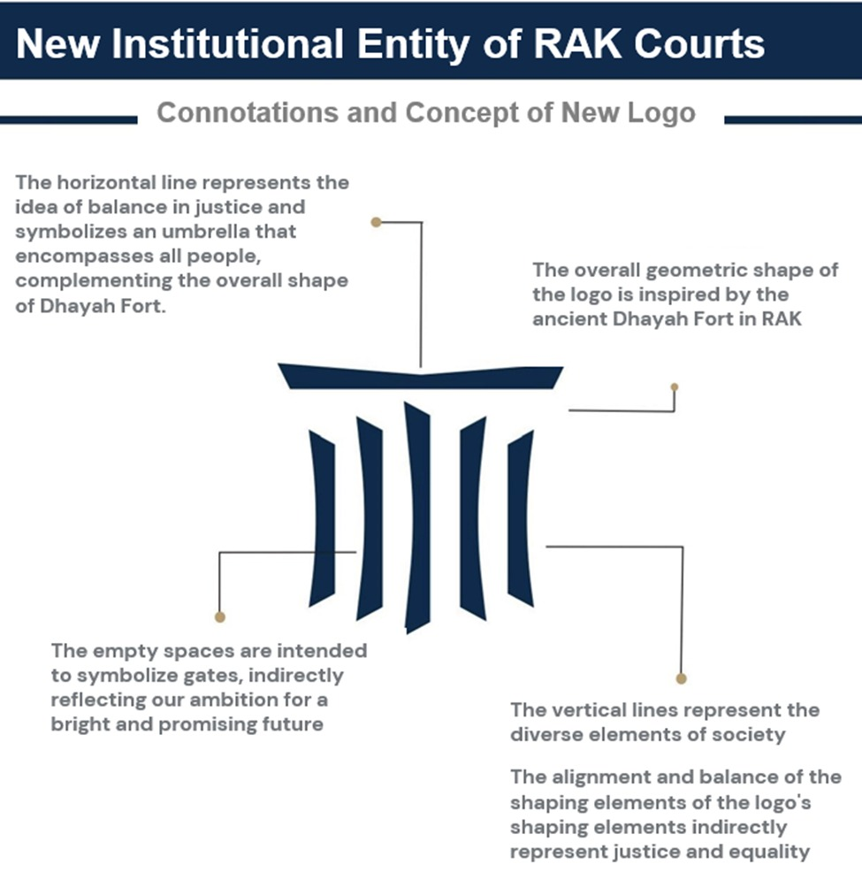
Photo 14: The launch of the corporate Identity

The launch of the courts’ new corporate Identity

